https://www.mycompiler.io/new/octave
Problem 1: Simulation and Analysis of 16-QAM Modulation in 5G NR
Implement and analyze a 16-QAM modulation scheme for 5G NR systems. Evaluate the Bit Error Rate (BER) performance over an AWGN channel and plot BER versus SNR.
- Develop a MATLAB/Octave simulation of 16-QAM modulation and demodulation.
- Transmit data through an AWGN channel.
- Analyze BER performance as a function of SNR.

Program:
clc;
clear;
close all;

% Parameters
M = 64; % Modulation order (4, 16, 64)
k = log2(M); % Bits per symbol
num_bits = 1000; % Total number of bits

% Generate random bits
bits = randi([0 1], num_bits, 1);

% Ensure length of bits is a multiple of k
num_symbols = floor(length(bits) / k);
bits = bits(1:num_symbols * k);

% Reshape bits into k-bit groups (each row = 1 symbol)
bit_groups = reshape(bits, k, num_symbols).';

% Manual binary to decimal conversion (replace bi2de)
powers_of_two = 2.^(k-1:-1:0);
symbol_indices = bit_groups * powers_of_two.'; % decimal symbol indices

% Generate QAM constellation points (square QAM only)
m_sqrt = sqrt(M);
if mod(m_sqrt, 1) ~= 0
error('M must be a perfect square for square QAM');
end

% Create I and Q points
I = -(m_sqrt - 1):2:(m_sqrt - 1);
Q = -(m_sqrt - 1):2:(m_sqrt - 1);

% Create meshgrid and flatten it
[II, QQ] = meshgrid(I, Q);
constellation = II(:) + 1j * QQ(:);

% Normalize constellation power to 1
constellation = constellation / sqrt(mean(abs(constellation).^2));

% Modulate: map indices to constellation points
tx_symbols = constellation(symbol_indices + 1);

% Plot transmitted symbols (Constellation Diagram)
figure;
scatter(real(tx_symbols), imag(tx_symbols), 'filled');
xlabel('In-Phase');
ylabel('Quadrature');
title([num2str(M) '-QAM Constellation (Transmitted Symbols)']);
grid on;

% Add AWGN Noise (Optional)
snr_db = 20; % SNR in dB
snr_linear = 10^(snr_db/10);
noise_variance = 1 / (2 * snr_linear);
noise = sqrt(noise_variance) * (randn(size(tx_symbols)) + 1j * randn(size(tx_symbols)));

rx_symbols = tx_symbols + noise;

% Demodulate: Find nearest constellation point
distances = abs(rx_symbols - constellation.');
[~, demod_indices] = min(distances, [], 2);

% Manual decimal to binary conversion (replace de2bi)
demod_bits = zeros(num_symbols, k);
for i = 1:k
demod_bits(:, i) = bitget(demod_indices - 1, k - i + 1);
end

% Reshape to column vector
demod_bits = reshape(demod_bits.', [], 1);

% Compute BER (Bit Error Rate)
num_errors = sum(bits ~= demod_bits);
ber = num_errors / length(bits);

% Display results
disp(['Number of bit errors: ' num2str(num_errors)]);
disp(['Bit Error Rate (BER): ' num2str(ber)]);

% Plot received symbols (With noise)
figure;
scatter(real(rx_symbols), imag(rx_symbols), 'filled');
xlabel('In-Phase');
ylabel('Quadrature');
title([num2str(M) '-QAM Constellation (Received Symbols with Noise, SNR = ' num2str(snr_db) ' dB)']);
grid on;

Results:
M=4
Number of bit errors: 0
Bit Error Rate (BER): 0

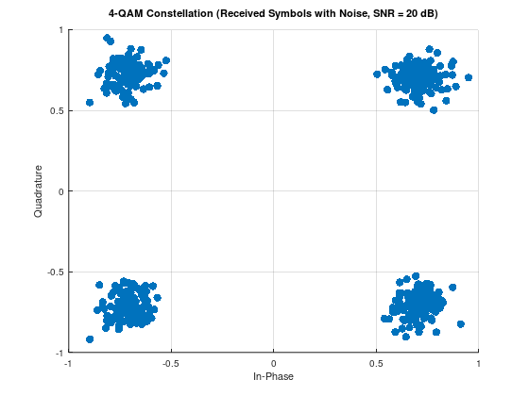
M=16
Number of bit errors: 0
Bit Error Rate (BER): 0

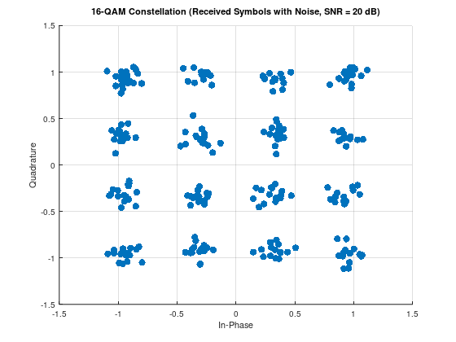

M=64
Number of bit errors: 11
Bit Error Rate (BER): 0.011044

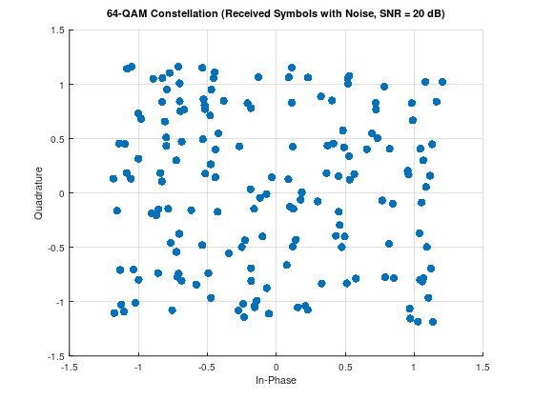

Problem 2: Adaptive Modulation and Coding (AMC) in 5G NR
Simulate an Adaptive Modulation and Coding (AMC) mechanism in 5G NR that dynamically selects modulation schemes (BPSK, QPSK, 16-QAM) based on varying SNR conditions.
- Implement SNR-based modulation adaptation.
- Evaluate BER and throughput performance for each modulation type.
- Demonstrate improved system efficiency through adaptive selection.

Program:
clc;
clear;

% Define SNR range
snr_range = 0:2:20;

% Thresholds for adaptive modulation
snr_threshold_qpsk = 5;
snr_threshold_16qam = 15;

% Initialize result storage
bits_per_symbol_all = zeros(size(snr_range));

% Loop over SNR range
for idx = 1:length(snr_range)
snr = snr_range(idx);

% Adaptive modulation selection
if snr < snr_threshold_qpsk
M = 2; % BPSK
scheme = 'BPSK';
elseif snr < snr_threshold_16qam
M = 4; % QPSK
scheme = 'QPSK';
else
M = 16; % 16-QAM
scheme = '16-QAM';
end

% Save results
bits_per_symbol = log2(M);
bits_per_symbol_all(idx) = bits_per_symbol;

% Display decision
disp(['SNR: ', num2str(snr), ' dB - Modulation: ', scheme, ' - Bits per symbol: ', num2str(bits_per_symbol)]);
end

% Plot bits per symbol vs SNR
figure;
plot(snr_range, bits_per_symbol_all, '-ob', 'LineWidth', 2, 'MarkerSize', 6);
grid on;
xlabel('SNR (dB)');
ylabel('Bits per Symbol');
title('Adaptive Modulation: Bits per Symbol vs SNR');

Result:
SNR: 0 dB - Modulation: BPSK - Bits per symbol: 1
SNR: 2 dB - Modulation: BPSK - Bits per symbol: 1
SNR: 4 dB - Modulation: BPSK - Bits per symbol: 1
SNR: 6 dB - Modulation: QPSK - Bits per symbol: 2
SNR: 8 dB - Modulation: QPSK - Bits per symbol: 2
SNR: 10 dB - Modulation: QPSK - Bits per symbol: 2
SNR: 12 dB - Modulation: QPSK - Bits per symbol: 2
SNR: 14 dB - Modulation: QPSK - Bits per symbol: 2
SNR: 16 dB - Modulation: 16-QAM - Bits per symbol: 4
SNR: 18 dB - Modulation: 16-QAM - Bits per symbol: 4
SNR: 20 dB - Modulation: 16-QAM - Bits per symbol: 4
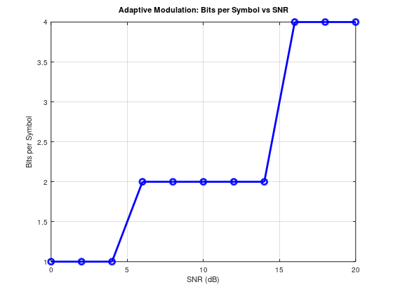

Problem 3: 5G NR Channel Coding using Parity-Check Codes
Implement basic channel coding in 5G NR using parity-check codes. Demonstrate error detection capability over an AWGN channel.
- Encode data using parity-check coding.
- Simulate transmission over an AWGN channel.
- Implement error detection and evaluate BER improvement.
Program:
clc;
clear;

% Parameters
M = 4; % QPSK
num_bits = 10000;
SNR_dB = 0:5:30;
BER = zeros(size(SNR_dB));

% Generate random bits
bits = randi([0 1], num_bits, 1);

% Manual QPSK Modulation
symbols = [];
for i = 1:2:num_bits
b1 = bits(i);
b2 = bits(i+1);
re = 2*b1 - 1;
im = 2*b2 - 1;
symbols = [symbols; (re + 1i*im)/sqrt(2)];
end

for idx = 1:length(SNR_dB)
snr = SNR_dB(idx);

% Add AWGN
noise = (randn(size(symbols)) + 1i*randn(size(symbols))) * 10^(-snr/20);
rx = symbols + noise;

% Demodulation
rx_bits = [];
for k = 1:length(rx)
re = real(rx(k));
im = imag(rx(k));
rx_bits = [rx_bits; re > 0; im > 0];
end

% BER
errors = sum(bits ~= rx_bits);
BER(idx) = errors / num_bits;
end

% Plot BER vs SNR
figure;
semilogy(SNR_dB, BER, 'bo-');
xlabel('SNR (dB)');
ylabel('BER');
title('QPSK over AWGN');
grid on;
Result:
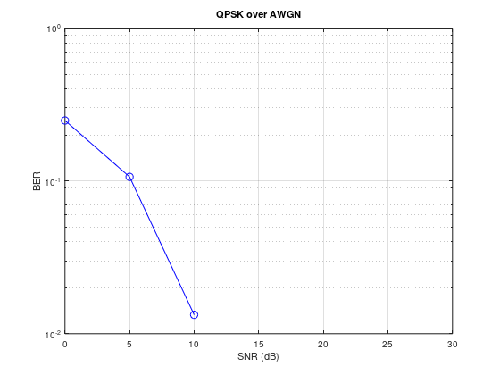

Problem 4: Basic OFDM Transmitter and Receiver Simulation for 5G NR
Implement a basic OFDM-based transmitter and receiver for 5G NR. Perform BER analysis over an AWGN channel.
- Simulate OFDM modulation (IFFT) and demodulation (FFT).
- Transmit data through an AWGN channel.
- Analyze BER versus SNR.

Program :
clc;
clear;
% --------------------------
% Parameters
% --------------------------
N = 64; % Number of subcarriers
CP_len = 16; % Cyclic prefix length
num_symbols = 100; % Number of OFDM symbols per SNR
M = 4; % QPSK (2 bits per symbol)
SNR_dB_range = 0:2:20; % SNR range in dB for BER plot
num_bits_per_symbol = log2(M);
num_total_bits = num_symbols * N * num_bits_per_symbol;

BER = zeros(length(SNR_dB_range), 1); % Initialize BER array

% --------------------------
% Start BER vs. SNR Simulation
% --------------------------
for idx = 1:length(SNR_dB_range)
snr_db = SNR_dB_range(idx);

% --------------------------------------
% Transmitter: Generate random data bits
% --------------------------------------
bits = randi([0 1], num_total_bits, 1);

% --------------------------------------
% QPSK Modulation (manual)
% --------------------------------------
symbols = zeros(length(bits)/2, 1);
for i = 1:2:length(bits)
b1 = bits(i);
b2 = bits(i+1);

% QPSK mapping: Gray coding
re = 2 * b1 - 1;
im = 2 * b2 - 1;

symbols((i+1)/2) = (re + 1i * im) / sqrt(2);
end

% --------------------------------------
% OFDM Modulation
% --------------------------------------
ofdm_symbols = reshape(symbols, N, num_symbols); % Reshape to N subcarriers
tx_signal = ifft(ofdm_symbols); % IFFT for OFDM modulation
tx_cp = [tx_signal(end - CP_len + 1:end, :); tx_signal]; % Add cyclic prefix
tx_serial = tx_cp(:); % Serialize

% --------------------------------------
% Add AWGN Noise (manual)
% --------------------------------------
signal_power = mean(abs(tx_serial).^2);
snr_linear = 10^(snr_db / 10);
noise_power = signal_power / snr_linear;
noise = sqrt(noise_power / 2) * (randn(size(tx_serial)) + 1i * randn(size(tx_serial)));
rx_serial = tx_serial + noise;
% --------------------------------------
% OFDM Demodulation
% --------------------------------------
rx_cp = reshape(rx_serial, N + CP_len, num_symbols);
rx_signal = rx_cp(CP_len + 1:end, :);
rx_ofdm_symbols = fft(rx_signal);
rx_symbols = rx_ofdm_symbols(:);
% --------------------------------------
% QPSK Demodulation (manual)
% --------------------------------------
rx_bits = zeros(length(bits), 1);
for k = 1:length(rx_symbols)
re = real(rx_symbols(k));
im = imag(rx_symbols(k));

rx_bits(2*k - 1) = re > 0; % First bit (real part)
rx_bits(2*k) = im > 0; % Second bit (imag part)
end

% --------------------------------------
% BER Calculation
% --------------------------------------
num_errors = sum(bits ~= rx_bits);
BER(idx) = num_errors / length(bits);

disp(['SNR = ' num2str(snr_db) ' dB, BER = ' num2str(BER(idx))]);
end

% --------------------------
% Plot BER vs. SNR
% --------------------------
figure;
semilogy(SNR_dB_range, BER, '-o', 'LineWidth', 2);
grid on;
xlabel('SNR (dB)');
ylabel('Bit Error Rate (BER)');
title('BER vs. SNR for QPSK-OFDM (No External Functions)');
legend('OFDM-QPSK');
Result:
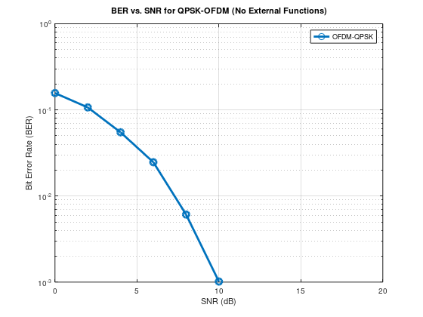
Problem 5: OFDM Transmission over Multipath Fading Channels with Cyclic Prefix in 5G NR
Simulate a 5G NR OFDM system with Cyclic Prefix (CP) and evaluate its performance over multipath fading channels.
- Implement Cyclic Prefix addition and removal.
- Model a multipath fading channel.
- Analyze BER performance under various SNRs and multipath conditions.

Program:
clc;
clear;

% Parameters
num_subcarriers = 64;
num_symbols = 50; % Reduced for faster simulation
cp_len = 16;
SNR_dB_range = 0:5:30;

% Multipath Channel
h = [0.8; 0.5*exp(1j*pi/4); 0.3*exp(1j*pi/3)];

% BER Initialization
BER = zeros(1, length(SNR_dB_range));

% SNR loop
for snr_idx = 1:length(SNR_dB_range)
SNR_dB = SNR_dB_range(snr_idx);
errors = 0;
total_bits = 0;

% Generate bits
num_bits = num_subcarriers * num_symbols * 2; % 2 bits per QPSK symbol
bits = randi([0 1], num_bits, 1);

% QPSK modulation
symbols = zeros(num_subcarriers, num_symbols);
for sym_idx = 1:num_symbols
temp_symbols = zeros(num_subcarriers, 1);
for sc = 1:num_subcarriers
idx = (sym_idx - 1) * num_subcarriers * 2 + (sc - 1) * 2 + 1;
b1 = bits(idx);
b2 = bits(idx + 1);
temp_symbols(sc) = (2*b1 - 1 + 1j*(2*b2 - 1)) / sqrt(2);
end
symbols(:, sym_idx) = temp_symbols;
end

% OFDM Modulation + CP insertion
tx_signal = [];
for i = 1:num_symbols
ifft_data = ifft(symbols(:, i));
ofdm_symbol_cp = [ifft_data(end - cp_len + 1:end); ifft_data]; % Add cyclic prefix
tx_signal = [tx_signal; ofdm_symbol_cp];
end

% Channel convolution
channel_output = conv(tx_signal, h);
channel_output = channel_output(1:length(tx_signal)); % Trim extra samples

% Add AWGN
signal_power = mean(abs(channel_output).^2);
snr_linear = 10^(SNR_dB / 10);
noise_power = signal_power / snr_linear;
noise = sqrt(noise_power / 2) * (randn(size(channel_output)) + 1j * randn(size(channel_output)));

rx_signal = channel_output + noise;

% Receiver: OFDM Demod + CP removal + Equalization
rx_symbols = zeros(num_subcarriers, num_symbols);
index = 0;
for i = 1:num_symbols
start_idx = index + cp_len + 1;
end_idx = index + cp_len + num_subcarriers;

if end_idx > length(rx_signal)
disp('Reached end of rx signal');
break;
end

r = rx_signal(start_idx:end_idx);
index = index + num_subcarriers + cp_len;

rx_ofdm = fft(r);

% Channel frequency response
H = fft([h; zeros(num_subcarriers - length(h), 1)]);

% Zero Forcing Equalizer
eq_ofdm = rx_ofdm ./ H;

rx_symbols(:, i) = eq_ofdm;
end

% Demodulation
rx_bits = zeros(num_bits, 1);
symbol_counter = 0;
for i = 1:num_symbols
for k = 1:num_subcarriers
symbol_counter = symbol_counter + 1;
rx_sym = rx_symbols(k, i);
rx_bits(2*symbol_counter - 1) = real(rx_sym) > 0;
rx_bits(2*symbol_counter) = imag(rx_sym) > 0;
end
end

% BER calculation
bit_errors = sum(bits ~= rx_bits);
BER(snr_idx) = bit_errors / num_bits;

disp(['SNR = ', num2str(SNR_dB), ' dB, BER = ', num2str(BER(snr_idx))]);
end

% Plot BER vs SNR
figure;
semilogy(SNR_dB_range, BER, 'ro-', 'LineWidth', 2);
xlabel('SNR (dB)');
ylabel('Bit Error Rate (BER)');
title('OFDM BER vs SNR over Multipath Channel');
grid on;
legend('QPSK-OFDM');
Result:
SNR = 0 dB, BER = 0.20703
SNR = 5 dB, BER = 0.090781
SNR = 10 dB, BER = 0.026562
SNR = 15 dB, BER = 0.0034375
SNR = 20 dB, BER = 0
SNR = 25 dB, BER = 0
SNR = 30 dB, BER = 0
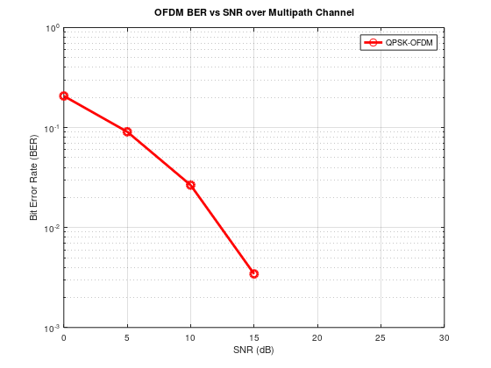

Problem 6: Exploring 5G NR Numerology (Subcarrier Spacing and CP Lengths)
Simulate different 5G NR numerologies by varying subcarrier spacing (SCS) and cyclic prefix lengths. Evaluate their impact on system performance.
- Implement multiple numerology configurations (e.g., 15 kHz, 30 kHz SCS).
- Analyze their effects on bandwidth, latency, and BER.
- Compare the trade-offs between different numerologies.
Program:
clc;
clear;

% Base parameters
f_ref = 15e3; % 15 kHz base subcarrier spacing
numerologies = 0:4; % µ = 0 to 4
fs = 30.72e6; % Sampling rate (for simplicity)

% Arrays to store results
SCS = zeros(size(numerologies));
CP_durations = zeros(size(numerologies));

for i = 1:length(numerologies)
mu = numerologies(i);
SCS(i) = f_ref * 2^mu; % Subcarrier spacing
Nfft = fs / SCS(i);
Ncp = Nfft * 0.07; % Assume CP is 7% of symbol length
CP_durations(i) = Ncp / fs * 1e6; % in microseconds
end

% Plot
figure;
subplot(2,1,1);
stem(numerologies, SCS/1e3, 'LineWidth', 2);
xlabel('Numerology Index (µ)');
ylabel('Subcarrier Spacing (kHz)');
title('5G NR Numerology: Subcarrier Spacing');
grid on;

subplot(2,1,2);
stem(numerologies, CP_durations, 'r', 'LineWidth', 2);
xlabel('Numerology Index (µ)');
ylabel('CP Duration (\mus)');
title('5G NR Numerology: CP Duration');
grid on;
Result:
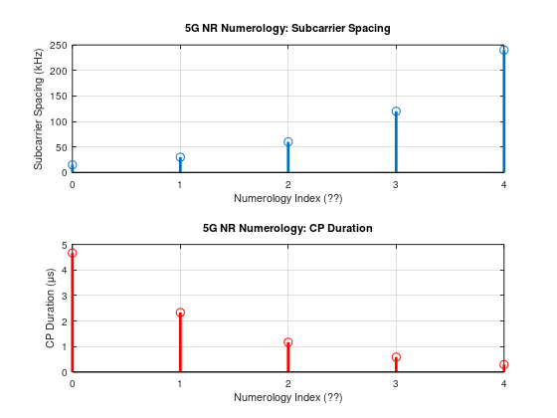

Problem 7: Simulation of 2x2 MIMO Spatial Multiplexing in 5G NR
Implement and simulate a 2x2 MIMO system using spatial multiplexing and Zero Forcing detection for 5G NR. Evaluate BER performance over AWGN and Rayleigh fading channels.
- Develop the 2x2 MIMO channel model.
- Implement Zero Forcing (ZF) receiver.
- Analyze BER performance under varying SNRs.

Program:
clc;
clear;
num_bits = 1000; % Reduced number of bits for faster execution
num_tx = 2;
num_rx = 2;
SNR_dB = 0:5:30;
BER = zeros(size(SNR_dB));

% Generate random bits
bits = randi([0 1], num_bits, 1);

% Manual QPSK Modulation
symbols = zeros(num_bits/2, 1);
for i = 1:2:num_bits
b1 = bits(i);
b2 = bits(i+1);
re = 2*b1 - 1;
im = 2*b2 - 1;
symbols((i+1)/2) = (re + 1i*im)/sqrt(2);
end

% Reshape into 2x streams
symbols_tx = reshape(symbols, num_tx, []);

num_symbols = size(symbols_tx, 2);

for idx = 1:length(SNR_dB)
snr = SNR_dB(idx);
errors = 0;

% Loop for all symbols
for n = 1:num_symbols
s = symbols_tx(:, n);

% Random channel matrix H
H = (randn(num_rx, num_tx) + 1i*randn(num_rx, num_tx)) / sqrt(2);

% Transmit signal through channel
y = H * s;

% Add noise
noise_power = 10^(-snr/10);
noise = sqrt(noise_power/2) * (randn(size(y)) + 1i*randn(size(y)));
y_noisy = y + noise;

% Zero Forcing Detection
s_est = pinv(H) * y_noisy;

% Demodulation
rx_bits = [];
for k = 1:length(s_est)
re = real(s_est(k));
im = imag(s_est(k));
rx_bits = [rx_bits; re > 0; im > 0];
end

% Original transmitted bits for comparison
tx_bits = [];
for k = 1:length(s)
re = real(s(k));
im = imag(s(k));
tx_bits = [tx_bits; re > 0; im > 0];
end

% Count bit errors
errors = errors + sum(rx_bits ~= tx_bits);
end

BER(idx) = errors / (num_symbols * num_tx * 2); % total bits transmitted
end

% Plot BER vs SNR
figure;
semilogy(SNR_dB, BER, 'r*-');
xlabel('SNR (dB)');
ylabel('BER');
title('2x2 MIMO Zero Forcing BER Performance');
grid on;
Result:
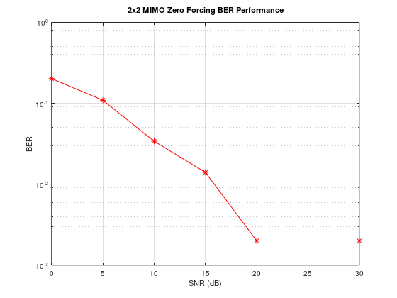

Problem 8: Uplink Massive MIMO Simulation with Zero Forcing Detection in 5G NR
Simulate a massive MIMO uplink system in 5G NR with multiple users and antennas. Apply Zero Forcing detection and evaluate BER performance.
- Model an uplink scenario with many users and receive antennas (e.g., 64 antennas).
- Implement Zero Forcing (ZF) linear detection.
- Evaluate system performance (BER vs. SNR).
Program:
clc;
clear;

% Reduced parameters for quick simulation
num_users = 2; % Number of user equipments (UEs)
num_bs_antennas = 4; % Number of base station antennas
num_bits_per_user = 100; % Reduced bits for faster run
SNR_dB = 0:5:30;

BER = zeros(1, length(SNR_dB));

% Generate random bits for each user
bits = randi([0 1], num_users, num_bits_per_user);

% QPSK Modulation
symbols = zeros(num_users, num_bits_per_user / 2);
for user = 1:num_users
tmp = zeros(num_bits_per_user / 2, 1);
idx = 1;
for i = 1:2:num_bits_per_user
b1 = bits(user, i);
b2 = bits(user, i+1);
re = 2*b1 - 1;
im = 2*b2 - 1;
tmp(idx) = (re + 1i*im)/sqrt(2);
idx = idx + 1;
end
symbols(user, :) = tmp.';
end

for idx = 1:length(SNR_dB)
snr = SNR_dB(idx);
errors = 0;
total_bits = 0;

for sym_idx = 1:size(symbols, 2)
x = symbols(:, sym_idx);

% Random Channel Matrix (Massive MIMO channel)
H = (randn(num_bs_antennas, num_users) + 1i*randn(num_bs_antennas, num_users)) / sqrt(2);

% Transmit Signal
y = H * x;

% Calculate signal power
signal_power = mean(abs(y).^2);

% Calculate noise power for given SNR
snr_linear = 10^(snr/10);
noise_power = signal_power / snr_linear;

% Generate noise with appropriate scaling
noise = sqrt(noise_power/2) * (randn(size(y)) + 1i*randn(size(y)));

% Received signal + noise
y_noisy = y + noise;

% Zero Forcing Detection
H_zf = pinv(H);
x_hat = H_zf * y_noisy;

% Demodulate each user
for user = 1:num_users
re = real(x_hat(user));
im = imag(x_hat(user));
rx_bits = [re > 0; im > 0];

tx_bits = [real(x(user)) > 0; imag(x(user)) > 0];

errors = errors + sum(rx_bits ~= tx_bits);
total_bits = total_bits + 2;
end
end

BER(idx) = errors / total_bits;

disp(['SNR = ' num2str(snr) ' dB, BER = ' num2str(BER(idx))]);
end

% Plot BER vs SNR
figure;
semilogy(SNR_dB, BER, 'bs-', 'LineWidth', 1.5);
xlabel('SNR (dB)');
ylabel('Bit Error Rate (BER)');
title('Massive MIMO Uplink with Zero Forcing Detection');
grid on;
Result:
(On licenced tool: num_users =8; % Number of user equipments (UEs)
num_bs_antennas = 64; % Number of base station antennas
num_bits_per_user = 1000; % Reduced bits for faster run)
NR = 0 dB, BER = 0.08
SNR = 5 dB, BER = 0.03
SNR = 10 dB, BER = 0
SNR = 15 dB, BER = 0
SNR = 20 dB, BER = 0
SNR = 25 dB, BER = 0
SNR = 30 dB, BER = 0
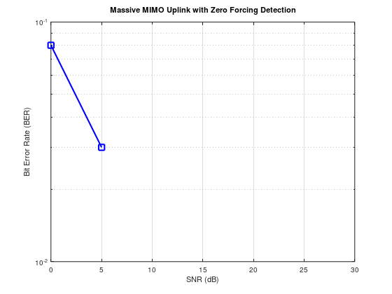

Problem 9: Beamforming Radiation Pattern Simulation for a 16-Element Uniform Linear Array (ULA)
Simulate and plot the beamforming radiation pattern of a 16-element ULA used in 5G NR Massive MIMO systems. Steer the beam toward a specified angle (e.g., 30°).
- Create a 16-element ULA antenna array model.
- Implement beam steering to the desired direction.
- Plot the radiation pattern (array factor) in dB.
Program:
clc;
clear;

% Parameters
N = 16; % Number of antennas in ULA
theta_deg = 30; % Desired steering angle (degrees)
lambda = 1; % Wavelength
d = lambda/2; % Antenna spacing
theta_rad = theta_deg * pi / 180;

% Steering Vector for ULA
n = 0:N-1;
steering_vector = exp(1j*2*pi*d/lambda*n*sin(theta_rad)).';

% Signal transmitted from base station with beamforming
signal = 1; % Example baseband symbol
tx_signal = steering_vector * signal;

% Assume receiver is in the same direction
rx_signal = steering_vector' * tx_signal;

disp(['Beamformed Received Signal: ', num2str(abs(rx_signal))]);

% Plot antenna array response
theta_scan = -90:1:90;
response = zeros(size(theta_scan));
for idx = 1:length(theta_scan)
t = theta_scan(idx)*pi/180;
sv = exp(1j*2*pi*d/lambda*n*sin(t)).';
response(idx) = abs(sv' * steering_vector);
end
figure;
plot(theta_scan, response);
xlabel('Angle (degrees)');
ylabel('Array Response (Magnitude)');
title('Beamforming Response of ULA');
grid on;

Result:
Input N=16; Output = Beamformed Received Signal: 16
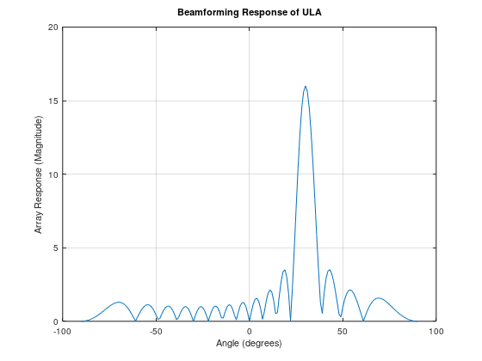
Problem 10: Path Loss Simulation for mmWave Transmission in 5G NR
Simulate the effect of path loss on mmWave signal transmission in 5G NR over varying distances. Plot received power versus distance.
- Model mmWave path loss using standard path loss equations.
- Simulate varying distances and analyze received power.
- Evaluate the impact of path loss on communication range.
Program:
clc;
clear;

% Parameters
freq = 28e9; % 28 GHz mmWave frequency
c = 3e8; % Speed of light
lambda = c / freq;
Pt_dBm = 30; % Transmit power in dBm
Gt_dB = 15; % Transmit antenna gain
Gr_dB = 15; % Receive antenna gain
distances = 1:1:200; % in meters

% Free Space Path Loss Model
FSPL_dB = @(d) 20*log10(d) + 20*log10(freq) - 147.55;

% NLOS additional loss (simple model: 20 dB penalty)
NLOS_penalty_dB = 20;

Pr_LOS_dBm = Pt_dBm + Gt_dB + Gr_dB - FSPL_dB(distances);
Pr_NLOS_dBm = Pr_LOS_dBm - NLOS_penalty_dB;

% Plot
figure;
plot(distances, Pr_LOS_dBm, 'b-', 'LineWidth', 2); hold on;
plot(distances, Pr_NLOS_dBm, 'r--', 'LineWidth', 2);
xlabel('Distance (m)');
ylabel('Received Power (dBm)');
title('mmWave Propagation: LOS vs. NLOS');
legend('LOS', 'NLOS');
grid on;
Result:
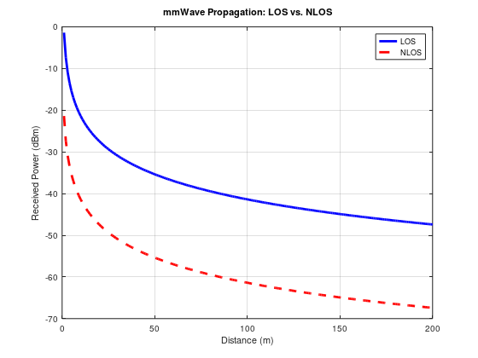

Problem 11: Pilot-Based Channel Estimation in 5G NR
Implement simple pilot-based channel estimation for 5G NR. Evaluate the accuracy of channel estimation in the presence of AWGN.
- Transmit pilot symbols in the channel.
- Perform Least Squares (LS) or Minimum Mean Square Error (MMSE) estimation.
- Compare estimated versus actual channel and evaluate BER.
Program:
clc;
clear;

% Parameters
num_subcarriers = 64;
num_pilot_subcarriers = 8;
pilot_indices = 1:8:num_subcarriers;
SNR_dB = 20;

% Generate random data and pilot symbols (QPSK)
data_bits = randi([0 1], num_subcarriers*2, 1);
data_symbols = [];
for i = 1:2:length(data_bits)
re = 2*data_bits(i) - 1;
im = 2*data_bits(i+1) - 1;
data_symbols = [data_symbols; (re + 1i*im)/sqrt(2)];
end

% Assign pilots
pilot_symbol = 1 + 1i; % fixed known pilot
tx_symbols = data_symbols;
tx_symbols(pilot_indices) = pilot_symbol;

% Channel (Random flat fading per subcarrier)
H_true = (randn(num_subcarriers,1) + 1i*randn(num_subcarriers,1)) / sqrt(2);

% Transmit through channel + noise
rx_symbols = H_true .* tx_symbols;
noise = (randn(num_subcarriers,1) + 1i*randn(num_subcarriers,1)) * 10^(-SNR_dB/20);
rx_symbols_noisy = rx_symbols + noise;

% Channel estimation using pilots
H_est = zeros(num_subcarriers,1);
H_est(pilot_indices) = rx_symbols_noisy(pilot_indices) / pilot_symbol;

% Simple interpolation for non-pilot subcarriers (zero-order hold)
for idx = 1:length(pilot_indices)-1
start_idx = pilot_indices(idx);
end_idx = pilot_indices(idx+1);
H_est(start_idx:end_idx) = H_est(start_idx);
end
H_est(end_idx:end) = H_est(end_idx);

% Equalization
eq_symbols = rx_symbols_noisy ./ H_est;

% Demodulation
rx_bits = [];
for k = 1:length(eq_symbols)
re = real(eq_symbols(k));
im = imag(eq_symbols(k));
rx_bits = [rx_bits; re > 0; im > 0];
end

% BER Calculation
errors = sum(data_bits ~= rx_bits);
ber = errors / length(data_bits);

disp(['Estimated BER after Channel Estimation: ', num2str(ber)]);

Result: Estimated BER after Channel Estimation: 0.48438

Problem 12: Device-to-Device (D2D) Communication in 5G NR
Simulate direct Device-to-Device (D2D) communication in 5G NR and compare BER performance with traditional cellular communication using relays.
- Model direct D2D communication and cellular relay-based communication.
- Analyze BER versus SNR for both approaches.
- Highlight the benefits of D2D communication in terms of spectral efficiency and latency.
Program:
clc;
clear;

% Parameters
num_bits = 10000;
SNR_dB = 0:2:20;
ber_d2d = zeros(size(SNR_dB));
ber_relay = zeros(size(SNR_dB));

for i = 1:length(SNR_dB)
% Generate random bits
bits = randi([0 1], num_bits, 1);

% BPSK Modulation
tx_symbols = 2*bits - 1;

% D2D Direct Link
noise = randn(size(tx_symbols)) * 10^(-SNR_dB(i)/20);
rx_symbols_d2d = tx_symbols + noise;
rx_bits_d2d = rx_symbols_d2d > 0;

% Relay Communication (Two hops, each with SNR loss)
noise1 = randn(size(tx_symbols)) * 10^(-(SNR_dB(i)-3)/20);
relay_signal = tx_symbols + noise1;

noise2 = randn(size(tx_symbols)) * 10^(-(SNR_dB(i)-3)/20);
rx_symbols_relay = relay_signal + noise2;
rx_bits_relay = rx_symbols_relay > 0;

% BER Calculation
ber_d2d(i) = sum(bits ~= rx_bits_d2d) / num_bits;
ber_relay(i) = sum(bits ~= rx_bits_relay) / num_bits;
end

% Plot
figure;
semilogy(SNR_dB, ber_d2d, 'b-o', 'LineWidth', 2); hold on;
semilogy(SNR_dB, ber_relay, 'r-s', 'LineWidth', 2);
xlabel('SNR (dB)');
ylabel('Bit Error Rate (BER)');
title('D2D vs. Relay Communication in 5G');
legend('D2D Direct Link', 'Relay Communication');
grid on;
Result:
